17.81: The tube is initially at temperature 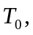 has sides of length 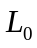 volume 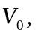 density 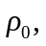 and coefficient of volume expansion 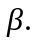

a) When the temperature increase to 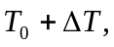 the volume changes by an amount 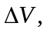 where 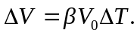 Then, 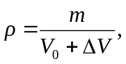 or eliminating 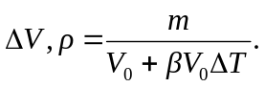 Divide the top and bottom by  and substitute 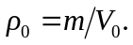 Then 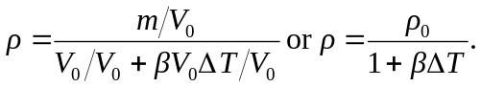 This can be rewritten as 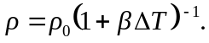 Then using the expression 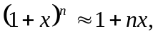 where 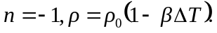

b) The copper cube has sides of length

Similarly, extra significant figures have been keep. So 